

Assignment No: 6

Date: 20th November 2026

Title: Information Theory

Name: David Tapia Caicedo

Course: Bachelor of Engineering in Electronic Engineering

Subject: Digital Communications and Transmission

Lecturer: Ben Graham

Summary: Sampling and reconstruction of a sine wave

AIM:
In this assignment, we will explore the fundamental findings of information theory including Entropy, Coding Efficiency, Block Coding, Shannon’s Lossless Source Coding Theorem, Shannon - Fano and Huffman Coding.

TOTAL MARKS:
100 Marks. (Remember complete all explanations and include all calculations)

OBJECTIVES:
Complete all text explanations, step by step mathematical calculations and insert required images directly within the designated sections below.

Total Marks : 100

All work must be completed and submitted inside THIS Document

Part 1 – Entropy (25 Marks)

Question 1: What unit is Entropy measured in? (3 Marks)

Answer 1:
The entropy is measured in bits.

Question 2: What is the relationship between Entropy and Shannon Information Content? (5 Marks)

Answer 2:
The Shannon information is how much, new and unpredictable data a specific message actually carries, and the entropy is the minimum number of bits required to transmit the message without losing information.

Question 3: Calculate the Shannon Information Content for each character and the overall Entropy H(x) of the following characters shown in Table 1.
(12 Marks)

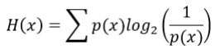

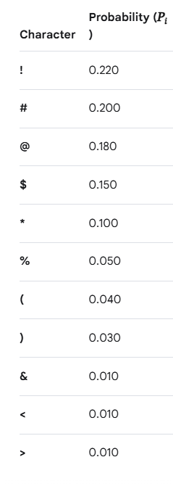

Table 1

Answer 3:
Shannon information content (h(x)) for every symbol are: “!” = 2.1844, “#” = 2.3219, “@” = 2.4739, “$” = 2.7370, “*” = 3.3219, “%” = 4.3219, “(“ = 4.6439, “)” = 5.0589, “&” = “<” = “>” = 6.6439.
And the overall Entropy (H(x)) = 2.886
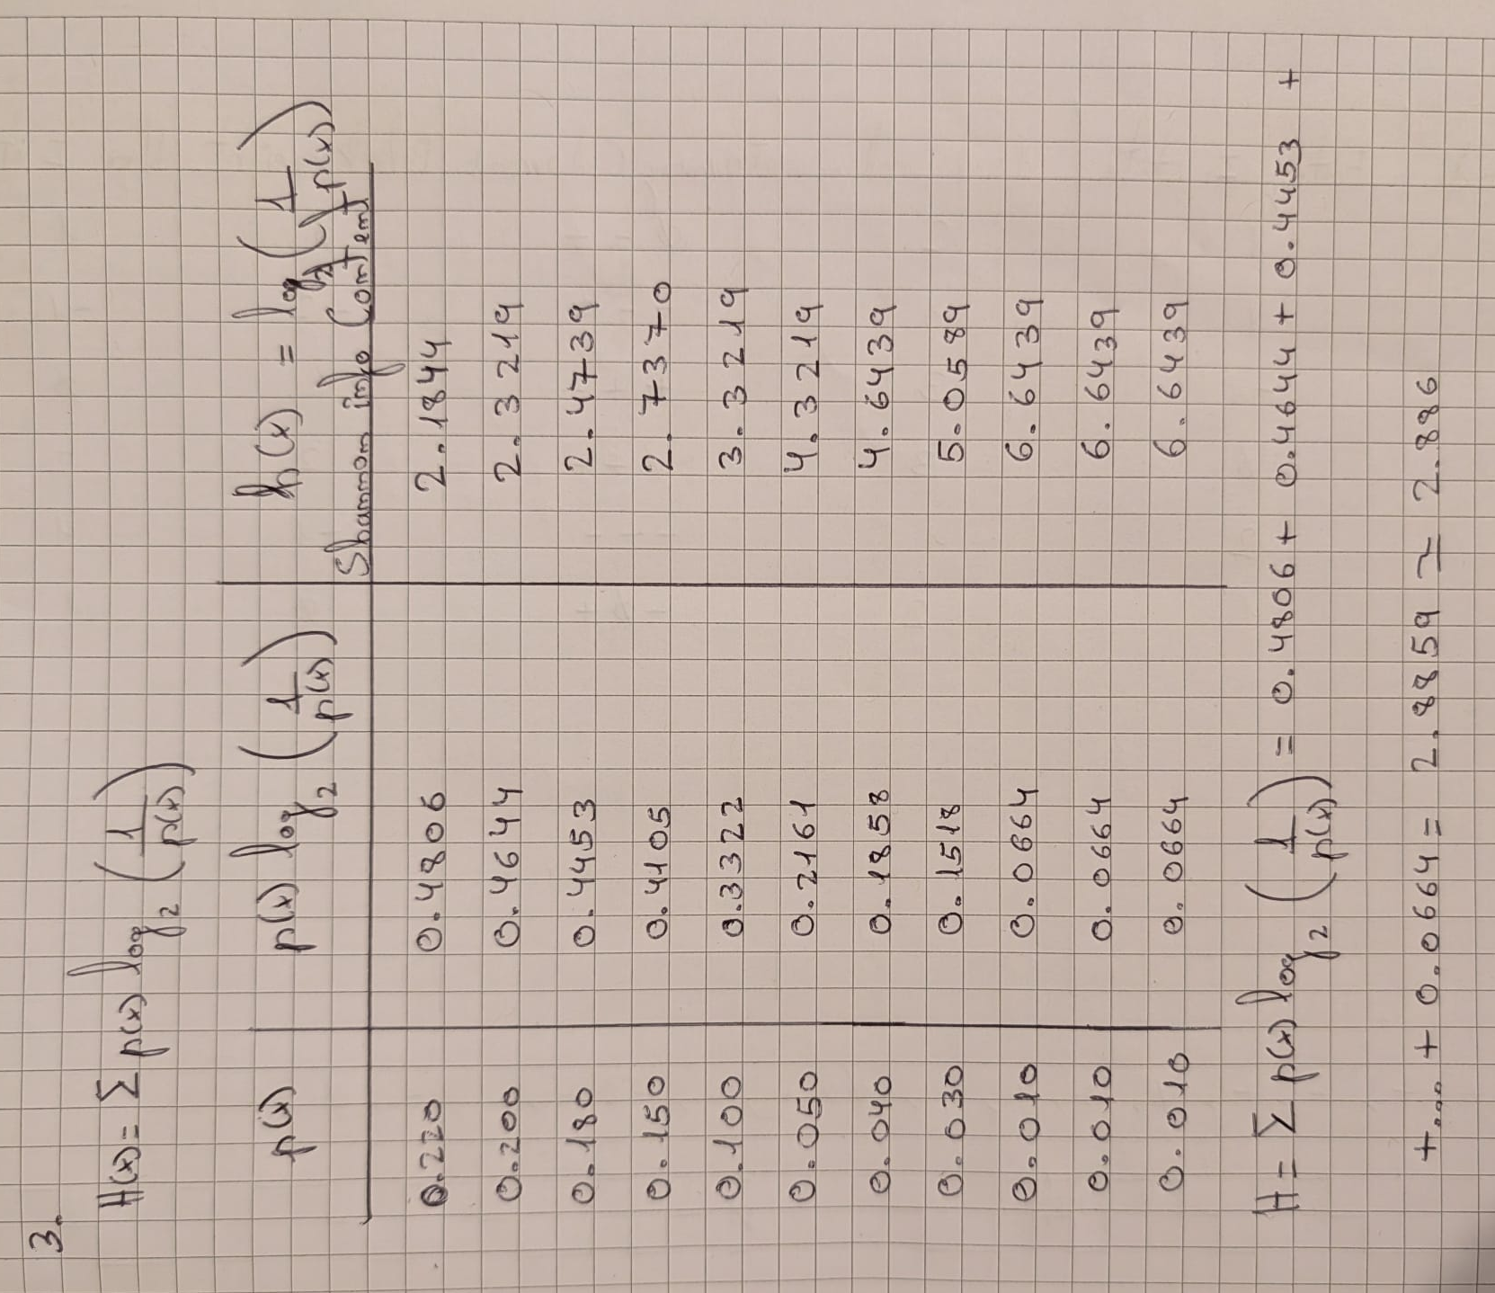
Figure 1: Calculations of Question 3 and 4

Question 4: Create a table and include the Shannon Information Content for each character and the overall Entropy. (3 Marks)

Answer 4:
The results were calculated using the same table in first place and a calculator using the formulas given in the Figure 1 or 2.

Figure 2: Calculations Question 3 and 4

Question 5: Using the python code provided. Confirm your calculated Entropy value.
(2 Marks)

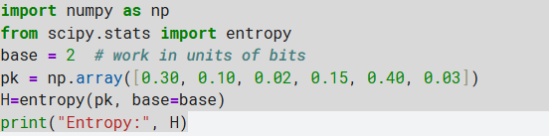

Or use the Entropy Calculator to check if your calculations are correct. https://planetcalc.com/2476/

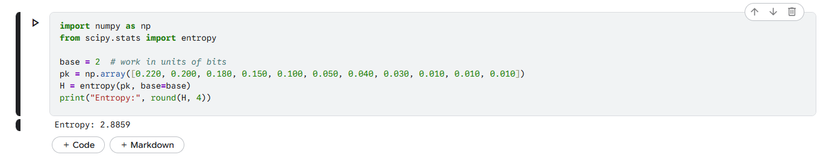
Figure 3: Entropy value calculated in Python

Answer 5 / Discussion:
As shown in Answer 3, the values presented in Figures 2 and 3 are the same, confirming the calculation is correct.

Part 2 – Coding and Compression Theory (20 Marks)

Question 6: Explain the difference between lossless and lossy compression?
(5 Marks)
Answer 6:
Lossless compression reduces file size without removing any actual information, meaning the original data can be reconstructed identically when decompressed. Meanwhile lossy compression data need not be exactly the same as the original data. Often, it’s enough to have a reasonably close approximation.

Question 7: Shannon formulated the theory of data compression and established that there is a fundamental limit to lossless data compression. What does this limit know as and what is it denoted as. (4 Marks)

Answer 7:
This limit is known as Entropy Rate and is denoted by H.

Question 8: Shannon-Fano and Huffman are types of lossless coding. Both coding methods are based on the same principles in the terms of character usage, frequency and code word length. Explain the overall principle behind them? (6 Marks)

Answer 8:
Shannon-Fano Huffman coding assigns or creates variable length codes to symbols based on their probabilities, so that more frequent symbols get shorter codes and less frequent symbols get longer.

Question 9: Which of the coding methods, Shannon-Fano or Huffman typically offers the greatest efficiency? (5 Marks)

Answer 9:
Huffman coding because this coding algorithm is one that is guaranteed to produce the fewest bits/symbol on the average.

Part 3 – Shannon Fano Coding (25 Marks)

Question 10: Explain the steps that must be taken to deduce a Shannon Fano code for a table of characters such as Table 1.
(5 Marks)

Answer 10:
The Shannon-Fano code has the source messages, a(i) and their probabilities p(a(i)). First source messages and probabilities are listed in order of decreasing probabilities. The list is then divided in such a way as to form two groups of as nearly equal probabilities as possible, each message in the first group receives a 0 as the first digit in its code word, the messages in the second half have codewords beginning with 1. Each of these 2 groups is then divided according to the same criterion and additional code digits added, and finally all these sequences are repeated until each subset contains only one message.

Question 11: Deduce the Shannon Fano code for Table 1. Perform on paper and include image of your working out and obtained codewords.
(10 Marks)

Answer 11:

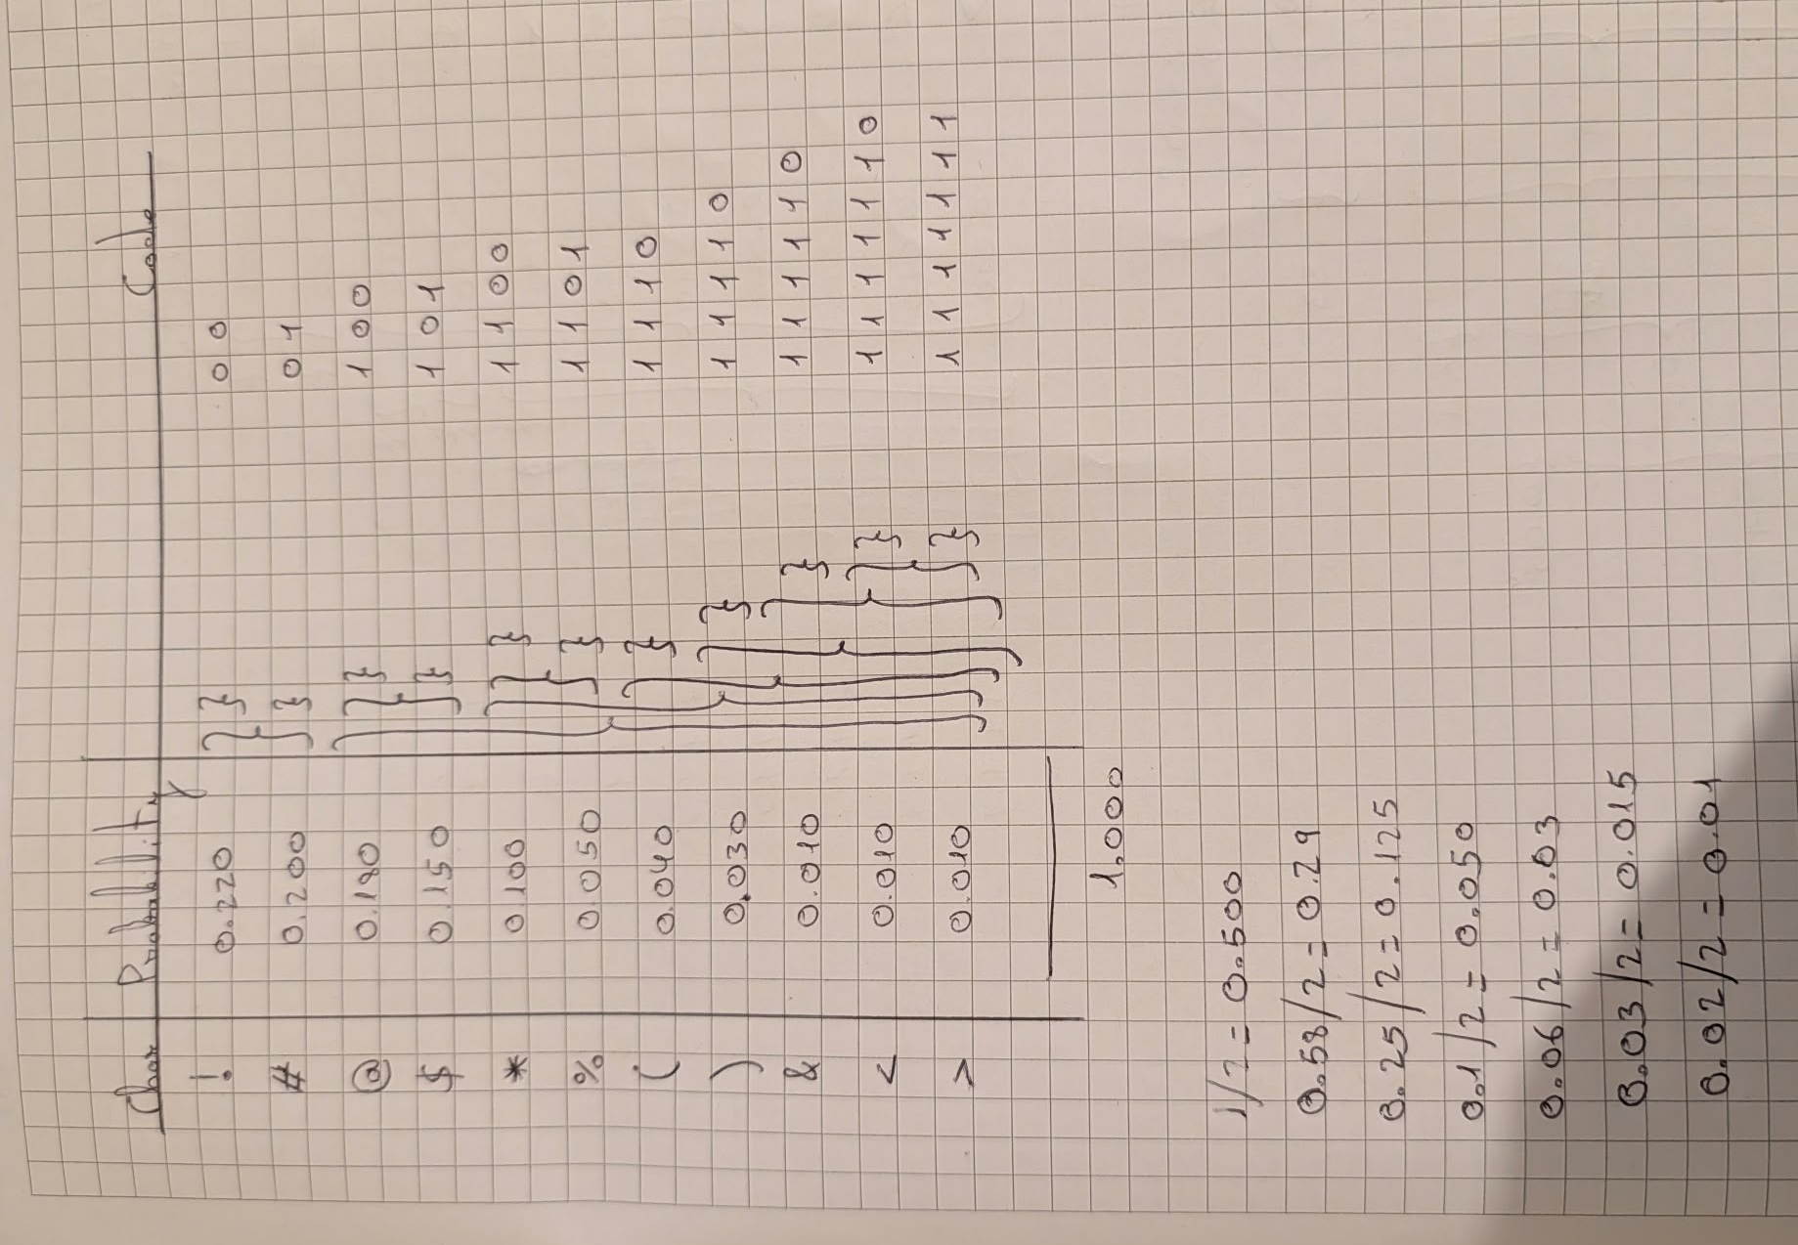
Figure 4: Calculate of Shannon Code

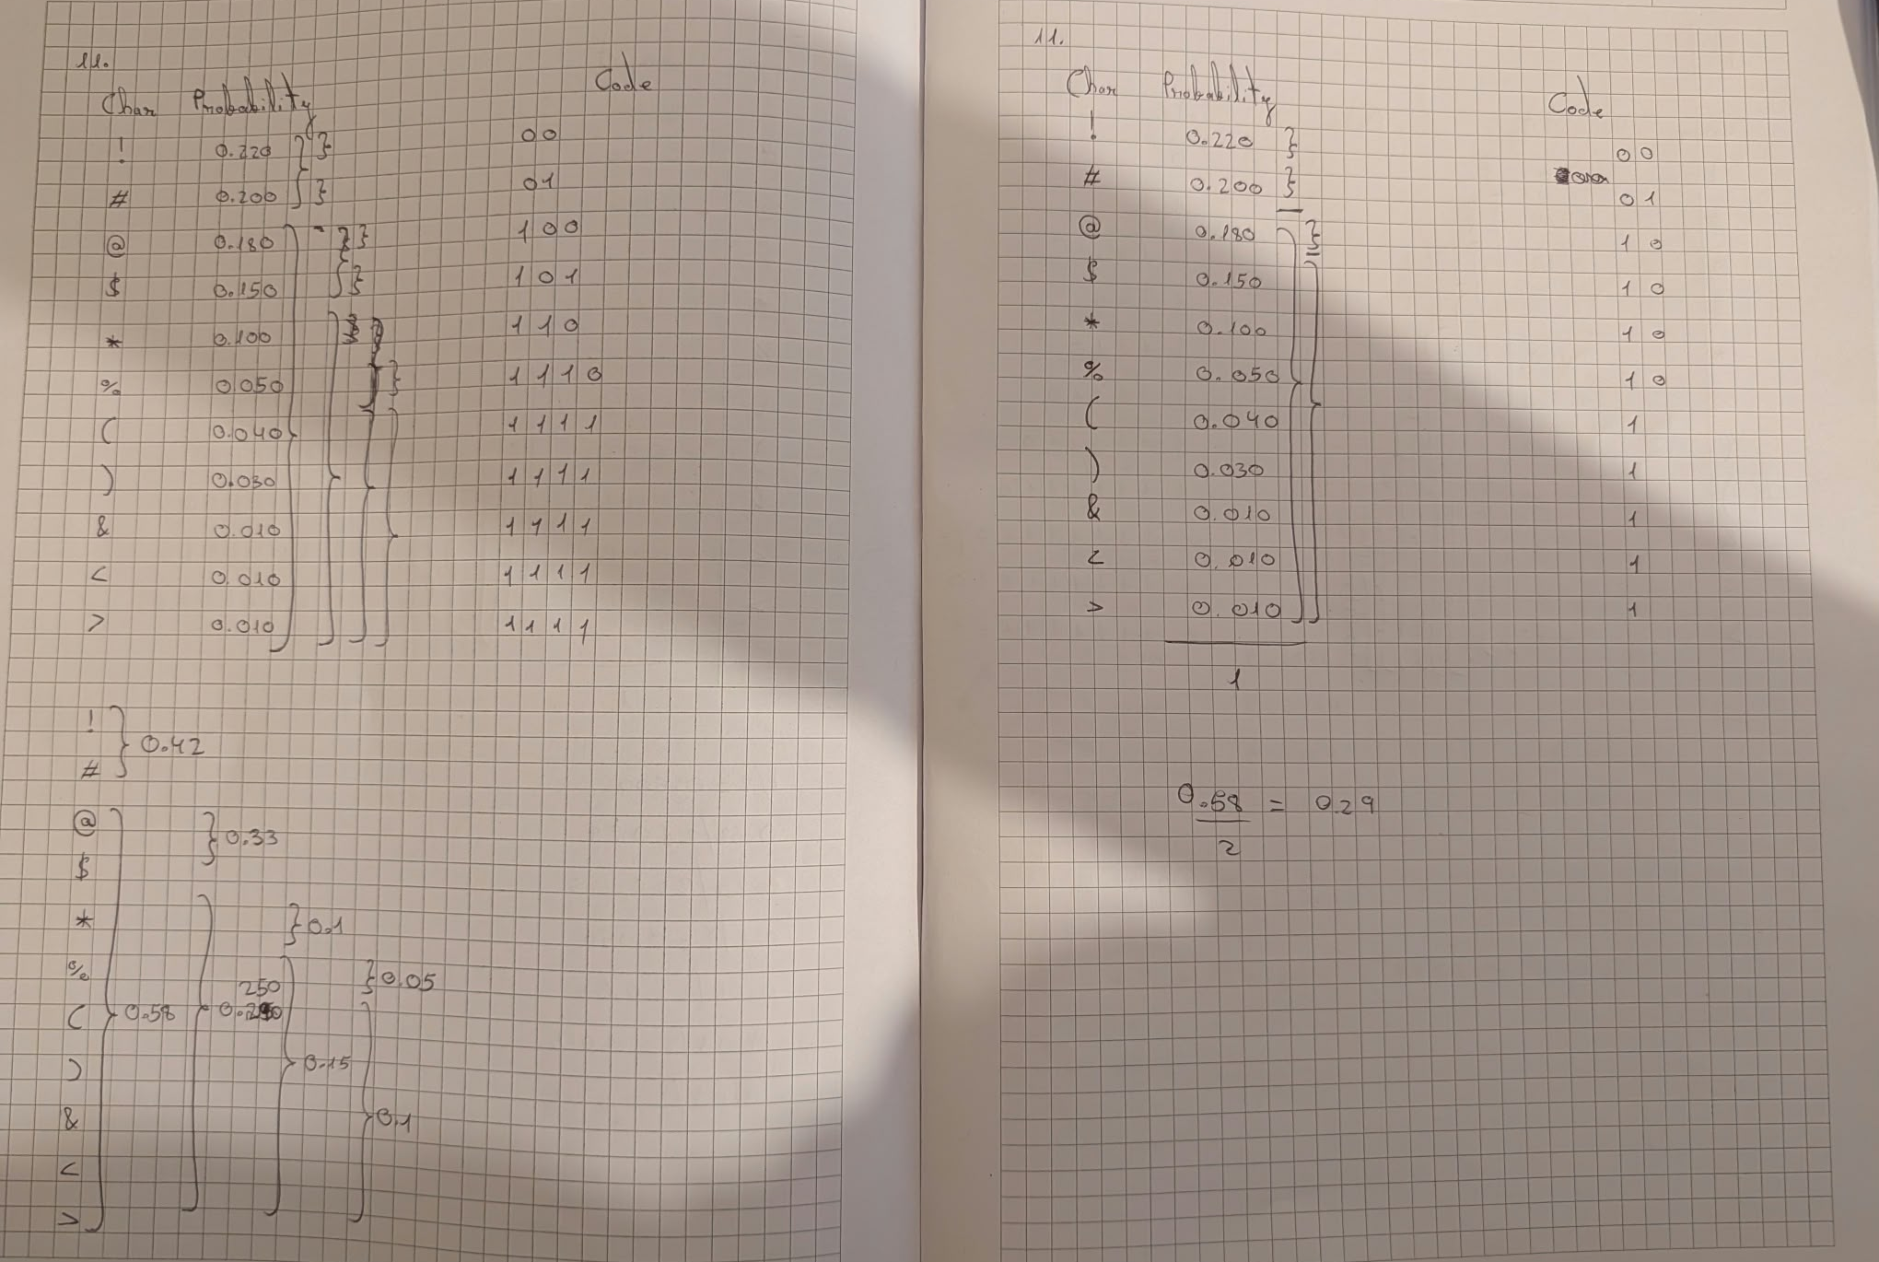
Figure 5: Attempts trying to calculate the Shannon Code

Question 12: Calculate the average number of bits (to 3 decimal places) produced by the coding method to represent the characters in Table 1.
(5 Marks)

Answer 12:

Place your image of your calculations here

Question 13: Calculate the efficiency of the coding obtained.
(5 Marks)

Place your image of your calculations here

Part 4 – Huffman Coding (30 Marks)

Question 14: Explain the steps that must be taken to deduce a Huffman code for a table of characters such as Table 1.
(5 Marks)
Answer 14:

Question 15: Deduce the Huffman code for Table 1. Perform on paper and include image of your working out and obtained codewords.
(15 Marks)

Place your image of your calculations and obtained codewords here

Question 16: Calculate the average number of bits (to 3 decimal places) produced by the coding method to represent the characters in Table 1.
(5 Marks)

Place your image of your calculations and obtained codewords here

Question 17: Calculate the efficiency of the coding obtained.
(5 Marks)

Place your image of your calculations here

Note: Submission
All questions to be answered and this document saved as a pdf and submitted on blackboard.

